PROJECT IN-CHARGE
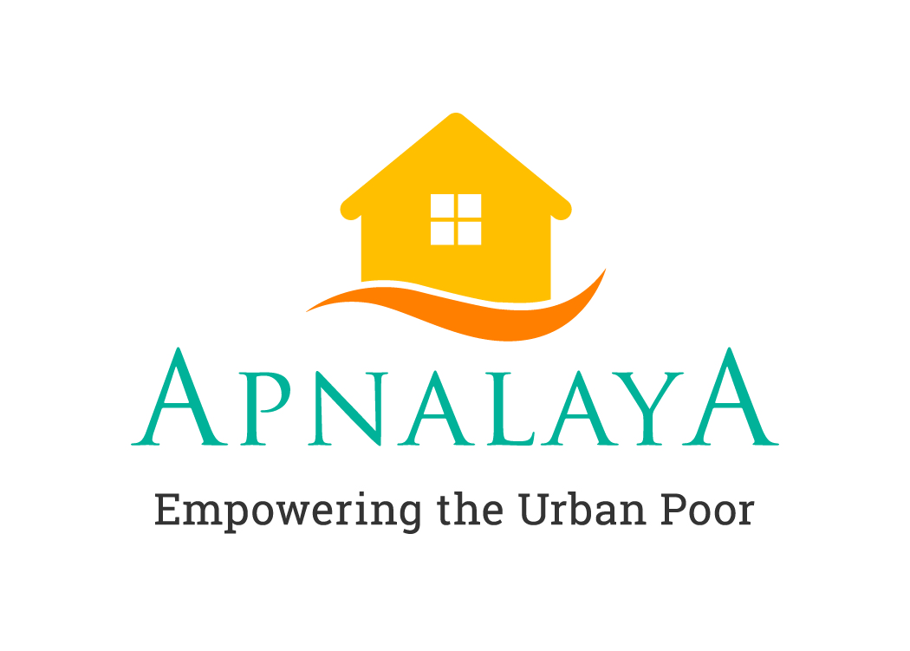

With increased urbanisation in India, the issue of urban poverty is on the rise - and will magnify if not tackled collectively. And no-where in India is this problem more pronounced, than in Mumbai. The urban poor struggle to survive, and are deprived of basic human needs – water, sanitation, nutrition, health and shelter. Inadequate access to healthcare, education and livelihood opportunities keeps them vulnerable.

Apnalaya works with the urban poor- Enabling access to basic services, healthcare, education and livelihoods; Empowering them to help themselves; and Ensuring provision of civic entitlements through advocacy with the government.

Our range of programs work at three different levels to help uplift the urban poor:

- INDIVIDUAL - We enable access to basic civic amenities, healthcare, education and livelihoods – necessary for individuals to survive, feel secure and grow.
- COMMUNITY – We empower the community to help themselves, by building their capacity as Volunteers.
- GOVERNMENT – We ensure the provision of civic entitlements through advocacy with the government.

JOB DESCRIPTION
A Project In-charge is responsible for the development, management, and execution of the Citizenship and Advocacy Programme. She/he works with the community, government, and civil society partners to equip marginalized urban people avail their entitlements. A C&A Project In-charge develops change-makers; facilitates the journey from “being people” to “becoming pro-active citizens”; invites people and communities on the margin to participate in their development.

Location: Chembur, Mumbai
Reports to the Director, C&A

- KEY RESPONSIBILITIES
Development and Management of the Programme

- Manage project deliverables, their timelines and quality
- Build partnerships with CSOs interested in our Citizenship approach
- Implement and monitor Citizenship Modules with new CSO partners, train community volunteers in civic action, and contribute to organisational advocacy efforts
- Develop relevant training and master training modules
- Contribute to any research, proposal writing, event, activity undertaken by the program and the organisation

Networking and Advocacy (Partnership Development)
- Maintain partnerships with other non-profits and educational institutions. Conduct and facilitate meetings with parents, school authorities, elected representatives and government officials
- Develop and manage partnership with the government, donors, supporters and maintain updated data-sheet of all the Networking and Advocacy partnerships
- Explore opportunities to bring new partners interested in the Citizenship curriculum
Team Management
- Manage, guide, mentor, and review the staff reporting in this position
- Identify capacity building needs, develop and facilitate capacity enhancement of the team
Budgetary Responsibilities
- Work with the Director to develop and manage programme budgets; develop monthly projections, monitor and settle expenses with due-diligence and compliance as per the Organisational and statutory norms
Organisational Responsibilities
- Contribute to and participate in any organisational initiative as decided upon by the Organisation
- Periodically share reports, stories of success and challenges with the Organisations.
QUALIFICATIONS & EXPERIENCE
Qualification and Skills
Experience/aptitude in urban governance, human rights, community empowerment, youth development, capacity building, advocacy and networking are critical to this role.
- A Master’s Degree in Social Work or Social Sciences
- A minimum of 5-year experience in working with informal settlements or any other marginalized communities
- Proficiency in English with excellent writing skills and proficiency in spoken Hindi are pre-requisites
- Computer proficiency in MS-Office
- Ability to manage complex projects is desirable
- Demonstrable leadership and management skills
BEHAVIOURAL COMPETENCIES
A team player, solution-oriented, self-driven professional with strong sense of empathy, equity, constitutionalism, integrity and ownership.

Send your application to: hr@apnalaya.org

